HEALTH
Dr. Oz Breaks Down Revealing How He Saved His Wife From Suicide Using a Strange Vick's Trick That Silenced Her Tinnitus Forever
After receiving a devastating diagnosis, the legendary doctor reveals the unexpected $3 discovery that silenced the ringing destroying his wife — and saved her from the same fate that took Texas Roadhouse founder Kent Taylor.
The world watched in shock as Dr. Mehmet Oz confessed his darkest fear in a recent interview: losing his wife Lisa the same way America lost Kent Taylor — the beloved CEO of Texas Roadhouse, who took his own life in 2021 when the ringing in his ears became unbearable.
"She sat on the floor one night, hands over her ears, shaking," Dr. Oz revealed, his voice cracking. "And through tears, she whispered the words I'll never forget: 'I can't take another night like this. I'm afraid of what I might do.'"
So, if you're suffering from constant ringing in your ears… if anxiety spikes every time the sound gets louder… if you're terrified the tinnitus will never stop…
You're NOT alone. And it's NOT your fault.
After Lisa's diagnosis, doctors gave Dr. Oz a cruel warning: tinnitus was chronic, progressive, and irreversible. They prescribed sound machines, hearing aids, and medications that only suppressed the symptoms — never the cause.
The ringing continued to destroy her nerves from the inside out.
But everything changed when Dr. Oz, desperate, stumbled onto a strange combination hiding in plain sight in his own kitchen — Vick's VapoRub and honey.
See what happened in Dr. Oz's exclusive interview with Anderson Cooper:

HEAD PRESELL TINNITUS - DR. OZ CRYING + WIFE WB.png

🅰️ Anderson Cooper "Mehmet, you've never spoken publicly about Lisa's tinnitus before. What changed?"
🅾️ Dr. Oz "What changed was Kent Taylor. When I read that he took his own life because of the same ringing Lisa was hearing every night — a man who had everything, who built Texas Roadhouse from nothing, who gave up his salary during COVID to help his employees — and the tinnitus still won… I knew Lisa was next. I couldn't let it happen."
🅰️ Anderson Cooper "That's heartbreaking. How did you find this discovery?"
🅾️ Dr. Oz "Lisa's father had suffered with tinnitus for over a decade. After losing him, I made a promise: I would find the real cause or die trying. After months buried in obscure biological studies, I stumbled onto something no one was talking about. A natural combination so unlikely, so ordinary, it almost felt like a joke. A simple mixture of honey and Vick's VapoRub. Two everyday items — but together, something far more powerful than anyone realized."
🅰️ Anderson Cooper "And it actually worked?"
🅾️ Dr. Oz "In 21 days, the high-pitched ringing softened. In 5 weeks, Lisa experienced full breathtaking silence — for the first time in 3 years. On day 17, she woke up and her eyes were different. 'For the first time in 3 years, I can hear the silence,' she whispered. That afternoon, she played piano for the first time in years, tears streaming down her face."
🅰️ Anderson Cooper "And you used this yourself to save her?"
🅾️ Dr. Oz "Exactly. Thanks to this natural protocol, my wife is back. The ringing is gone, her sleep returned, the fog lifted — she finally feels like herself again. I recorded a full free video explaining how to do it at home, and I'd like to ask you to roll a clip."
🅰️ Anderson Cooper "How could I say no? Of course. So if you or someone you love has been struggling with constant ringing, tinnitus, or even early hearing loss, please watch this video now. Production, roll the Vick's Trick video."

See the interview.png
[Click Here To Watch The Video Right Now]
Finally, Dr. Oz had one request for our viewers:
"Please share this video with your friends and loved ones. Together, we have the power to save as many seniors as possible from the same fate that took Kent Taylor — and to give them back the silence they deserve."

See Other Celebrities Who Also Silenced Their Tinnitus

Eric Clapton.png
“I’ve suffered with tinnitus since my early 40s. I spent years bouncing between ENT doctors, sound therapy, meditation apps, and expensive supplements. Nothing made a real difference — until I followed Dr. Oz’s Vicks Trick together with the NeuroSilence protocol. Within a few weeks, the piercing tone faded into a soft background hum, and for the first time in years I slept through the night.”
Whoopi GoldBerd.png
“It feels like someone finally reached in and turned the volume knob down in my brain. I’m so grateful this method was finally made public. People like me deserve more than ‘learn to live with it’.”

We invited Dr. Oz and his longtime research partner Dr. Phil to reveal all the details of the 7-second Vick's Trick. They shared — for free — how to prepare this recipe at home, why it's so effective, and much more.
See the interview.png
[Click To Watch The Video]

Attention
UPDATE: Thousands of people across the country are now accessing this information and reporting impressive improvements in their tinnitus and sleep within just weeks.
Due to massive demand after Dr. Oz's video — which surpassed 2 million views in just 24 hours — we can only guarantee access for a limited time.
The powerful pharmaceutical lobby has already begun legal action to suppress this content and prevent the public from discovering this natural solution for reversing tinnitus.

🔴 Attention:
The longer you wait, the worse the nerve inflammation can get. According to clinical data, each week of delay can reduce your chances of full tinnitus recovery by up to 8%.

See the interview.png
[Click To Watch The Video]
958 Comments on the Post  Margaret Thompson  My husband has lived with tinnitus for almost 6 years. We’ve spent thousands on sound machines, therapies, appointments… nothing ever worked. Last month I watched this interview and finally understood why no one could help him. For the first time in years, he slept through the night last week. I’m crying as I write this. Thank you, Dr. Oz, for having the courage to speak publicly.  Thomas Baker  I’m 72. Been hearing ringing for over 3 years. My doctor kept saying “you’ll learn to live with it.” But it’s NOT normal to be afraid of silence. Watched the interview last night. Starting to dig deeper into this. If this helped people who were told there was no hope, it deserves to be seen.  Robert Chen  I’m a neurologist. 29 years in practice. What Dr. Oz is saying about tinnitus being neurological and not just “ear damage” is absolutely true. There is research that never made it past funding stages because it didn’t fit the existing treatment model. Many of us know this. Few are willing to say it publicly.  Michelle Davis  Thank you for finally saying what patients have been feeling for years. My ENT literally shrugged and said, “At least it’s not life-threatening.” Living with constant noise IS life-altering. This should never have been minimized.  Robert Chen  Exactly. Tinnitus is dismissed because it doesn’t show up clearly on scans. But nervous system hyperactivity is very real. Doctors who challenge the status quo risk being labeled “controversial.”  James Wilson  My wife’s tinnitus destroyed her sleep, her mood, and eventually our marriage. Not because we didn’t love each other, but because exhaustion changes people. Hearing that there may have been another explanation this whole time makes me furious. How many lives have been quietly damaged because “there’s nothing we can do”?  Linda Rodriguez  I’m 67. Had ringing and buzzing for almost 4 years. Brain fog, anxiety, no sleep. Watched this interview and everything finally clicked. I don’t feel crazy anymore. Just understanding what’s happening to my nervous system brought relief. This information matters.  Michael Anderson  I was skeptical at first. Another dramatic story, right? But then I thought about it. Dr. Oz doesn’t need attention. He didn’t gain anything by exposing this. He talked because it affected his family. That’s not marketing. That’s desperation turning into truth.  Patricia Garcia  My dad is 74 and has had tinnitus since his late 60s. Doctors told us to “ignore it.” We watched this interview together. For the first time, he said, “So it’s not just in my head.” I can’t explain what that meant to him. Everyone dealing with tinnitus deserves to hear this.  David Martinez  Why is this not being talked about everywhere? Probably because there’s more money in long-term management than real answers. Sound devices, therapies, appointments forever. A nervous system explanation changes everything.  Susan Taylor  I showed this to my audiologist, expecting him to dismiss it. Instead, he watched the whole thing quietly and said, “This actually makes sense.” He admitted many patients don’t respond to standard approaches. That honesty alone was shocking.  William Brown  My wife lived with severe tinnitus until the day she passed. It robbed her of sleep and peace for years. Finding out now that there may have been another way to understand what was happening is heartbreaking. Please share this. No one should suffer in silence because the system stopped asking questions.  Jennifer White  I’m 55. Started experiencing ringing, pressure, and panic last year. My doctor suggested antidepressants. I refused. After watching this interview, I finally feel validated. I’m not weak. My nervous system has been stuck in overdrive. This gave me hope I didn’t have before. | 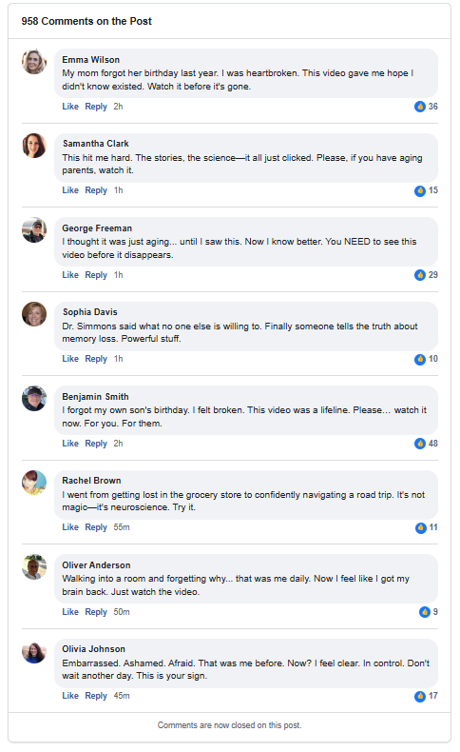

[Click Here To Watch The Video Right Now]

